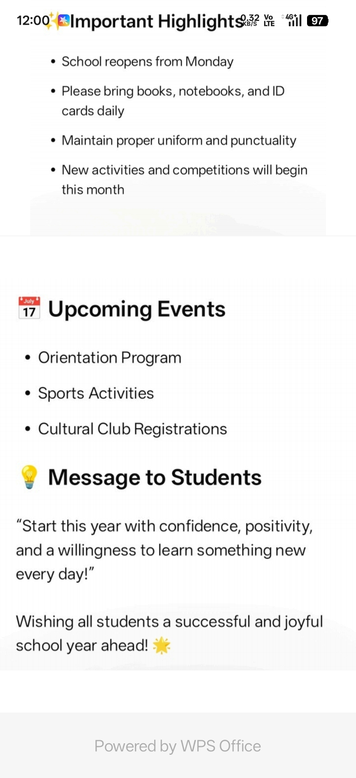
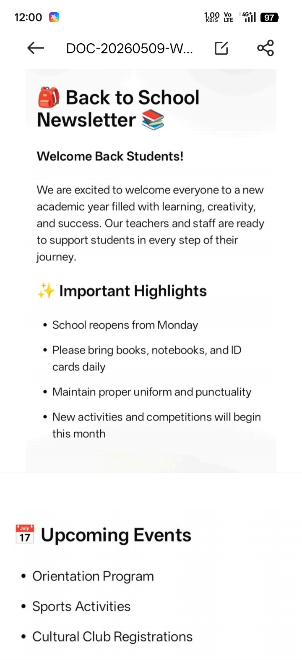
Wishing all students a successful and joyful new school year ahead!
Back to School Newsletter

